We are pleased to announce the Globe Business Park Liftshare scheme is now available. The scheme has been launched to support staff with parking, help cut congestion in the surrounding area as well as save staff travel costs.
- The scheme enables staff to add their commute and match with others making a similar route, so they can share their journey;
- It is completely free;
- It is flexible - you can be the driver or passenger on the days that you want to share;
- It offers the ability to split costs - regular sharers can save on average over a £1,000 a year!
- There is no obligation to share or commit to sharing regularly – you share whenever and however you want;

Sign up now at globebusinesspark.liftshare.com!

How to use Globe Business Park Liftshare scheme
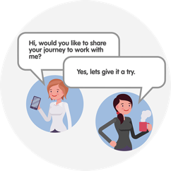
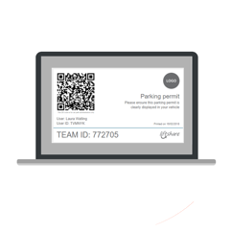
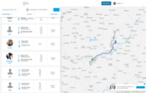
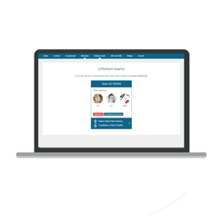
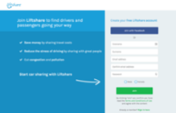
Create a Liftshare team
3
Find a match
2
Register for free
1

- Sign up to globebusinesspark.liftshare.com. You can then add your journey as either a passenger, driver or both;

- Search for a journey match and send a request to share – either ‘ask to share’ within the passenger section or ‘message’ within the driver section;

- If you already car share with an employee (s), they will need to register for you to match on the system. Your email address is kept hidden and is not shown to other members anywhere on the site;

- Create a Liftshare Team by confirming that you are sharing by accepting a request to share.

Globe Business Park Launch Days
The Liftshare Ambassadors will be at Globe Business Park on Tuesday 26 and Wednesday 27 March 2019 – come and speak to us:

- They will be hosting a stand in Coopers Café from 10am until 4pm and visiting businesses across site;
- Everyone who completes a sign-up form at Coopers Café will be automatically entered in to a prize draw to win a John Lewis Hamper - winner will be announced on Friday 29th March 2019!
- You will have the opportunity to ask them any questions you have and sign up to the scheme – it’s free!

Sign up and win a Fitbit ALTA HR!

Time to get fit and healthy for the summer!

- Sign up to globebusinesspark.liftshare.com;
- Complete this by Sunday 7 April 2019 for a chance to win!

Form a Liftshare Team and win £100 ‘Red Letter Days’ voucher!

Why not share an adrenaline-packed adventure with your Liftshare Team member/s?

- Sign up to globebusinesspark.liftshare.com;
- Form a Liftshare Team - post your journey, find a match and either send or accept a request to share;
- Complete this by Sunday 7 April 2019 for a chance to win;
- More information about ‘Red Letter Days’ vouchers can be found here: https://www.redletterdays.co.uk/.

My Personalised Travel Plan (myPTP)
Staff also have the option to receive a free ‘My Personalised Travel Plan’ (myPTP).
You will receive one email which outlines all your sustainable travel options for your journey in to work, including Liftshare matches.
Come and speak to the Liftshare Ambassadors to opt-in and receive a plan. They will be at Globe Business Park on Tuesday 26 and Wednesday 27 March 2019 visiting businesses and hosting a stand in Coopers Café from 10am until 4pm.

More Information

If you have any questions or would like to find out more about using the scheme, please visit globebusinesspark.liftshare.com.

Travel Happy!
